ODS Performance Report at Q3 (2018/19)

Introduction
- ODSL and ODSTL commenced trading on 1st April 2018 and this is a year to date report as at the end of Q3 (so performance up to and including December 2018).

Executive Summary
- Service performance has been consistently good all year with one quarter remaining
- However we want to be sure we have a deep understanding of the customer view and make desired changes to the service where we can. We’ve worked on improving our understanding of Building Services and Streetscene customer satisfaction in more depth – with changes being introduced as a result.
- At the three-quarter year (FY 2018/19), ODS remains on target to deliver this year’s Medium Term Financial Plan target of £1.4M profit after tax.
- We are also on track to cover the £0.5M start-up costs in this financial year.
- In addition to this, we predict there will be an opportunity for an additional dividend of £300k subject to approval under the Dividend Policy.
- Progress has been made against all year one objectives set out in the Business Plan
- Whilst managing the day to day business, we have determined the basis of a plan for the future which sets out not only how we will deliver the current MTFP growth targets but build on these so that by FY 2022/23 we will significantly increase the return. A detailed business case is progressing well for future approval by the Shareholder
- Improving our management of health & safety continues to be a priority and we’ve had a great 83% response rate to a workforce safety culture survey. This will inform our action plan.

Q1 – Q3 update:

Service Performance

- ODS meet with OCC partners to review the service on a monthly basis. During this meeting we review KPIs, finance and identify any areas requiring particular focus (these include city centre cleaning, establishing a construction pipeline, budget process, etc.).

- We at ODS monitor many performance indicators, thirty eight of which are target driven. The Council focuses on eight key areas: Tenant satisfaction, housing repairs, voids, streets, parks, waste & recycling, highways and car parking. Appendix 2 shows the current performance across measured KPIs year to date at Q3. The Client KPI headlines are in table 1 below.

- We are also on track to deliver the year 1 Business Plan objectives as shown at Appendix 1.

Table 1

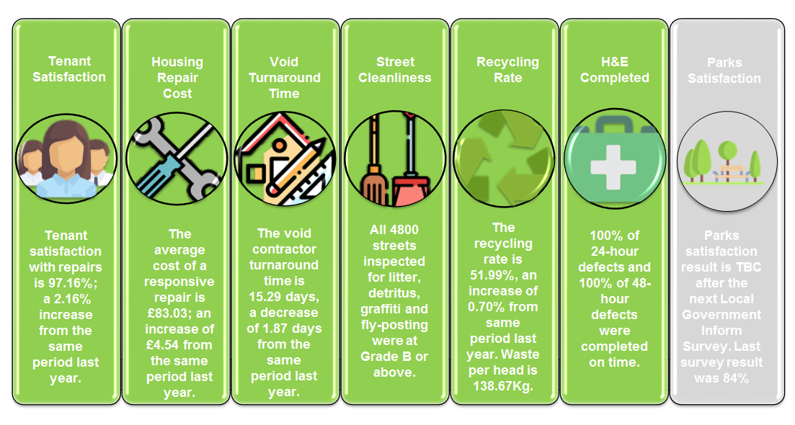

Customer Service

- ODS is continuing to focus on customer satisfaction and is using feedback received to prioritise issues, address them and drive through improvement. We have been developing ways to positively encourage feedback on our services via a range of methods. So far this has been successful and the business has used data within buildings and Streetscene to start to deliver improvements (see below).

- Buildings – developed an improved interface between contact centre staff and ODS to enable them to handle tenant enquiries more effectively. Identified themes to help us continue to develop and improve the service i.e. customer service training, providing literature to tenants to enable them to proactively manage issues such as damp and mould and to assist them in understanding the level of service and targets that we are contracted to deliver to.

- We are continuing to obtain lots of data from our customers to measure satisfaction and although the response rates could be better there’s enough data to draw conclusions:

- Work continues on transformation of our repairs and maintenance service and we expect these changes will increase satisfaction over the coming months.

- Streetscene – the service continues to meet the KPI’s but we don’t think these reflect the public view of street cleanliness. To address this we have developed, promoted and implemented a bespoke survey for Streetscene focusing on four key areas and have a achieved a return of almost 400 responses (see table below) which has given a good baseline to work from:

STREETSCENE SURVEY FEEDBACK | Average  Rating  (Score 1-5)
Cleanliness of my street | 3.54
Cleanliness of the City Centre | 3.44
Frequency of litter bin emptying | 3.35
Satisfaction with public toilets | 2.74

- Concern with city centre toilets - in response to this we are intensifying the programme of deep cleaning for those facilities. Demand on the toilets, particularly in Market Street, is far beyond the constrained capacity of the site and we will work with our building colleagues to consider what other options are available for us to address this. For some the experience of the city centre toilets is great such as “The toilets for example by the Covered Market are always clean and tidy”, and we need to make this the norm. We are exploring the value of operating managed toilets in Gloucester Green and Market Street and will report back to Members in due course. Any proposal will very likely give rise to additional costs which the Council as Client will need to consider in a future budget round.
- Rough sleeping - Perception of the city centre being negatively affected by the prevalence of rough sleeping. We work closely with Safer Oxford on the removal of rough sleeper debris and drugs paraphernalia. We largely have a good working relationship with this group so that we can do our job. However the impact on the City centre toilets is much more difficult to control with the removal of rough sleepers from cubicles being a significant problem. Removal from one facility usually only displaces to another city centre facility.
- Cowley Road and neighbouring area – general satisfaction although specific concerns relating to trade waste and litter building up during the day. We are working with colleagues in waste and recycling to address instances where waste is mis-presented (and as such not collected) and are introducing a dedicated resource through a redesign of rounds to collect litter throughout the day.

- Quality and Cleanliness of Pavements in the City - there is a continuing programme looking at resurfacing of paved areas with St Aldates due for significant investment in March (Western side between Carfax and Pembroke Street). This will both improve the appearance and safety of the paving but also make the surface easier to clean.
- Fly tipping – where it’s our area of responsibility we will immediately address the issue. Where it’s other areas we raise with appropriate stakeholder e.g. Safer Oxford, Housing (tenant properties only), etc

- The data being captured will assist us in focusing on prioritising the areas our customers believe are the most important and, in turn, inform work programmes and schedules going forward.

- In addition to the above, Streetscene are working in partnership with schools to develop a litter campaign and want to expand this across all schools in Oxford. We are also working collaboratively across ODS to join up services e.g. the City Council and ODS have won the Team off the Year award (the Recycling & Waste Team) from the Keep Britain Tidy organisation.

- We have also commenced clearing graffiti on the basis we have agreed with the Portfolio holder i.e. let’s focus on getting it done, rather than chasing small cost recovery from private householders and small businesses. This has led to some quick wins in Jericho, Meadow Lane and on the Thames bridges.
Health & Safety

- ODS continues to improve on its safety performance against previous years with a third quarter below trend from the same position in last year (see table 2 below). The Board receives a quarterly report on Health & Safety looking at leading and lagging indicators, compliance issues and any initiatives programmed in.
- Following on from the quarter 2 report which highlighted the activities around the capture and analysis of the “Safety Climate” within the organisation, the survey tool has now closed. The survey ran from the beginning of December until the 1st of February and netted a response in excess of 83% of the workforce. With an all industry national average of 61%, our engagement and response was a great success.

- The resulting responses are currently being analysed and will help inform improvements in safety management that is more in tune with the needs and perceptions of our workforce. Initial indications point to gaps in understanding in the reporting of incidents and “near miss” events and the perception of how objective and transparent the ensuing investigations are. We also have work to do around how “user friendly” some of our procedures and processes are in relation to work activities. On a positive note, the physical environment or situational aspects of the organisation relating to the plant, equipment and personal protective wear is highly valued and appreciated.

- The output from this Safety Climate survey (coupled with the scheduled health and safety management system audit which will be conducted by BDO later in February) will help us:
- better understand the perceptions of the workforce
- work to build more meaningful engagement and communication
- make safety management a more integrated part of how we conduct ourselves in our work activities every day

